
.
OUR LORD JESUS CHRIST, KING OF THE UNIVERSE  NOVEMBER 26, 2017


Sat. Nov. 25 VIGIL-OUR LORD JESUS CHRIST, THE KING
4:00pm Eugene Natoli by Mary Ann Chiodo

Sun. Nov. 26 OUR LORD JESUS CHRIST, KING OF THE UNIVERSE
8:30am Lynn Marie Stanchak by M/M Protus Phillips
9:45am For the People of the Parish

Mon. Nov. 27 WEEKDAY THIRTY-FOURTH WEEK IN ORDINARY TIME
8:30am Communion Service & Novena of the Miraculous Medal

Thurs. Nov. 30 SAINT ANDREW, APOSTLE
8:30am Communion Service & Rosary

Sat. Dec. 2 VIGIL-FIRST SUNDAY OF ADVENT
4:00pm Evan Bozzo by Mary Knowles

Sun. Dec. 3 THE FIRST SUNDAY OF ADVENT
8:30am Stephen Proch by M/M Steve Proch
9:45am For the People of the Parish

HOLY DAY OF OBLIGATION
IMMACULATE CONCEPTION
OF THE BLESSED VIRGIN MARY
December 7-VIGIL 6:30pm
December 8-8:30am

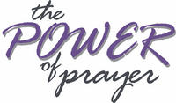
Parishioners who are sick and in need
of prayers can be added to our prayer
list by calling the Parish Office at
570-842-4995. Please pray for:
Jenny Filingo, Jerry White, Jennifer Simis, Alan Lemech, Vincent Orazi, Ben Topar, Craig Bozzacco, Donald Migliorato, Werner Henes, Phyllis Braun, Richard Major, Vonette Castelblanco, Bill Vockroth, Jane Colwell, Michael Begy, Jeanne Kopyta, Bob Jantz, Scott Carr, Suzanne Cicero, Robert Asinari, Muriel Calame, Carol Lippman, Matthew Gertz, Michael Klein, Arline Chumacas, Jamie Jantz, Karen Jantz, Jason Scott Taylor, Donna Lewis, Joanne Arredondo, Vincent Natoli and all the sick of the Parish.

Our Pilgrim Statue of the Blessed Virgin Mary

If she has not yet visited your home and you would like information or to sign up to have the Statue visit your home, please call Pat Manago at 570-848-2284.
This is where the statue will be traveling in the
weeks to come: 11/26-Manago Family 12/3-Tobin Family 12/10-Proch Family 12/17-OPEN 12/24-OPEN 12/31-OPEN



CHECK OUT OUR
WEBSITE OF THE MONTH
www.wordonfire.org

STEWARDSHIP OF TREASURE:


11/19/17
ENVELOPES (71): $ 1266.00
LOOSE: $ 327.00
INSURANCE (42): $ 243.00

TOTAL: $ 1836.00

11/19 11/12 11/5 10/29
PEOPLE ATTENDING: 4:00PM 57 70 72 70
8:30AM 54 57 57 54
9:45AM 69 84 76 66

THANK YOU FOR YOUR GENEROSITY

KEEPING UP WITH YOUR WEEKLY SUPPORT
If you miss attending mass here at your parish church
due to vacation, illness or other reason, please
make-up your donation when you return.

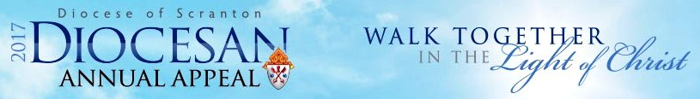
IN-PEW DIOCESAN APPEAL PLEDGE
THIS WEEKEND.
Thank you to those who have already joined us as we
“Walk Together in the Light of Christ” by making a pledge to the Diocesan Annual Appeal. On behalf of all who benefit from your gifts, Bishop Bambera extends his sincere gratitude to everyone who has already made a pledge to the 2017 Diocesan Annual Appeal. Each gift truly matters. If you have not yet made your gift, please consider making a pledge this weekend—Annual Appeal pledge envelopes will be distributed at the Masses. UPDATE ON THE ANNUAL APPEAL: Your gifts support the following ministries made possible by the Appeal:
- Catholic Social Services and Parish Social Justice Grants
- Catholic Education in Schools and Parishes
- Clergy Formation, Education and Support
- Parish Life and Ministry Formation
- Catholic Media and Communication
Our Goal: $15,000.00
(67%)Total Raised: $10,110.00
Over(Under): ($4,890.00)

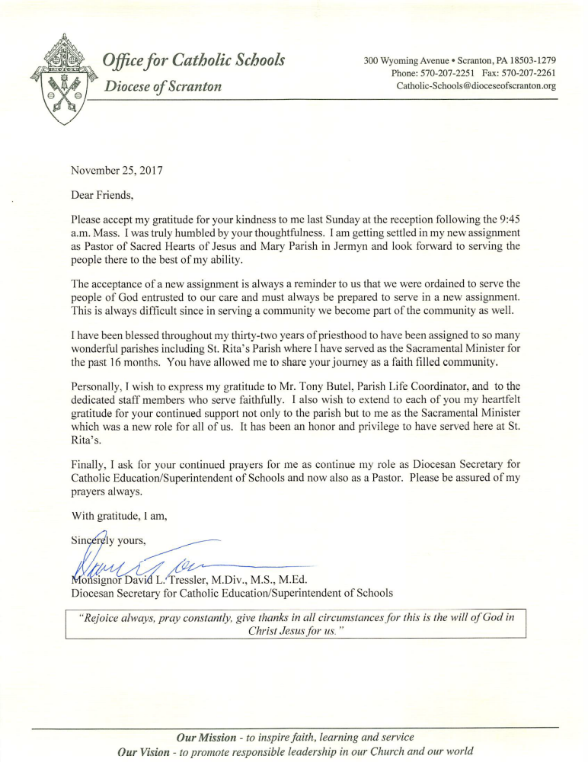

The 10 Commandments of Thankful Living by: Robert H. Schuller© Copyright Hour of Power 2006. This message was delivered by Robert H. Schuller from the pulpit of the Crystal Cathedral.
#1 Be thankful for prayers answered, known and unknown. Yes, take time to think about all the prayers God has answered for you in the past. Some of these prayers that have been answered are prayers that you didn’t pray. Others were praying for you ... friends, parents, grandparents. Maybe you sat on your grandpa or your grandma’s knee and they were praying for you. I’ll tell you something about prayer: Prayers are seeds ... and they can last a long, long time. Be thankful for prayers answered: known and unknown.
#2 Be thankful for habits, broken or avoided Think about how blessed you really are. Thank God that you are not addicted to one of the many destructive addictions such as alcohol, heroin, cocaine, or if you are, be thankful that these addictions can and will be broken starting now. Thank God for the support groups available that stand ready to help with these life crushing addictions.
#3 Be thankful for sins forgiven, both public and private We all have committed sins that people know about and sins that nobody knows about and may never discover, but are known only to you, your conscience and your God. So no matter what it is, you can be happy if you can go to bed at night, put your head on the pillow and know that you have no guilt. What a privilege to carry everything to Jesus in prayer."
#4 Be thankful for healings, seen and unseen You can see scars. You can recall the surgery. There are these known and obvious symbols of healing. But pause and think a minute of all the hidden hurts, the unrevealed wounds, the quiet, secret torturing memories that you carried with you. Then there was that moment when God touched you and healed you of your hurt. This church is a place where hurts are healed.
#5 Be thankful for the storms of your life that have blown out, blown over or passed you by and never touched you. Give thanks to God for all the narrow escapes you’ll never know about. You and I will never know how often our lives have been spared, how close we came to being at the intersection when the accident happened and we could have been involved. You will never know in your life, what infectious germs touched your body but never took root and you never became ill! Yes, thank God for storms which blew out, blew over, passed us by and never touched us.
#6 Be thankful for friends, old and new How lonely life would be without friends. And take time to remember old friends, especially if you’re down and discouraged. Take time and write on a piece of paper the friends that have meant the most to you in your life. Go back to your childhood: who was the little girl or the little boy you walked to school with? Who was your favorite teacher? Who was the favorite friend on your block? Who was the schoolmate? Think of all these friends, the old ones, the present ones, the new ones, and then stop and think: "Some of the best friends in your life, you haven’t even met yet!"
#7 Be thankful for impossibilities that become possibilities It is so easy to forget past blessings. We can get so blinded by something that isn’t happening today that we focus on the unanswered prayers instead of the answered prayers. We look at what we’ve lost instead of what we have left. We get hung up on our failures instead of our triumphs, our successes and our achievements. Think of the impossibilities that became possibilities. Thank God for impossibilities that became possibilities.
#8 Be thankful for gifts, given and received Pause and think about the gifts you’ve received, but most of all, thank God for the joy of giving. Each time in our ministry when I call on members of the church who are shut in, I am the one who is blessed. I visit them and give them an uplifting, encouraging thought. In the process, I discovered that it really is true: it is impossible to give of yourself without receiving something immediately. Thank God for gifts given and for gifts received.
#9 Be thankful for the possibilities that God put WITHIN you There are possibilities within each of us that have been discovered and developed, but there are others that remain undiscovered and undeveloped. So, be thankful for possibilities that are blossoming. Be thankful that the world hasn’t seen the best of you yet. If you’re not happy with what you see, stick around. God is still at work in you.
#10 Be thankful for hope that springs eternal and never dies If you visit the Crystal Cathedral gardens, you will see a Norfolk pine tree. This tree was planted twenty years ago. Do you know what it means to plant a tree? When you plant a tree, it means you have faith in tomorrow. Are you disappointed or discouraged today? Give your story a happy ending. Thank God for the hope that springs eternal.

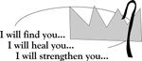
STEWARDSHIP OF TALENT:
Nov. 26, 2017 OUR LORD JESUS CHRIST, THE KING
LECTORS:
Nov. 25th 4:00pm Ed Kosmahl
Nov. 26th 8:30am Richard Colwell
9:45am Lyne Van Houtte
EXTRAORDINARY MINISTERS OF THE EUCHARIST:
Nov. 25th 4:00pm A. Hynes/S. Lenzer
Nov. 26th 8:30am P. Manago/M. Chiodo
9:45am K. Fossetta/M. Croak
ALTAR SERVERS:
Nov. 25th 4:00pm Alan/Sue Hynes
Nov. 26th 8:30am Veronica Yanulavich
9:45am A. Proch/B. Fossetta
HOSPITALITY & USHERS:
Nov. 25th 4:00pm Andrew Kelemen/Victor Benfatti
Nov. 26th 8:30am Tom Volpe/E. Sennefelder
9:45am Frank Kopyta/Richard Erazmus

Dec. 3, 2017 THE FIRST SUNDAY OF ADVENT
LECTORS:
Dec. 2nd 4:00pm Kealy Ford
Dec. 3rd 8:30am Jim Kohn
9:45am Kathy Fossetta
EXTRAORDINARY MINISTERS OF THE EUCHARIST:
Dec. 2nd 4:00pm B. Negri/M. Rounsavill
Dec. 3rd 8:30am T. Butel/V. Yanulavich
9:45am T. Butel/L. Van Houtte
ALTAR SERVERS:
Dec. 2nd 4:00pm Alan/Sue Hynes
Dec. 3rd 8:30am Amanda Proch
9:45am S. Lenzer/A. Hull
HOSPITALITY & USHERS:
Dec. 2nd 4:00pm Andrew Kelemen/Victor Benfatti
Dec. 3rd 8:30am Ed Snyder/Tom Volpe
9:45am Frank Kopyta/Tom Quinn

ADVENT SEASON BEGINS DECEMBER 3
The parish will be offering the little blue book for all parishioners this Advent season, but following is an on-line invitation for Advent from Dynamic Catholic:

Christmas is a time of hope, but during the busy holiday it’s easy to get overwhelmed and lose sight of the reason for the season. Next Advent, take an incredible journey to rediscover the gift of hope.

Join us for Best Advent Ever! Every day during Advent you’ll receive short inspirational videos, practical tips, or real-life stories that will help you experience a Christmas full of hope. Are you ready for your best Advent—and Christmas—ever?
https://dynamiccatholic.com

PICK UP A LITTLE BLUE BOOK AFTER ALL THE MASSES.


UPCOMING CLASSES
Dec. 3, 10, 17

December 3-Faith Formation Rosary-
Families Welcome
December 17-5th & 6th Grade Parent Meeting
and Children’s Mass.

Notice Regarding Reporting Sexual Abuse of a Minor
It is the policy of the Diocese of Scranton to report any allegation of sexual abuse of a minor to law enforcement. If you are a victim of sexual abuse committed by a priest, deacon, religious or lay employee or volunteer of the Diocese of Scranton, you are encouraged to immediately report the matter to law enforcement. If any priest, deacon, religious, lay employee or volunteer of the Diocese of Scranton has cause or reason to suspect that a minor has been subjected to any form of abuse, including child sexual abuse, the matter will be reported to law enforcement. In accordance with the Commonwealth of Pennsylvania’s Child Protective Service Laws, reports of suspected child abuse should also be made immediately by phone to the 24-Hour Child Abuse hotline (ChildLine) at 1-800-932-0313 or electronically at www.compass.state.pa.us/cwis.
It is also the policy of the Diocese to adhere to all civil and state regulations. To this end, the Diocese is equally committed to adhering to the norms of the Code of Canon Law and to upholding the tenets of the USCCB Charter for the Protection of Children and Young People, which includes supporting victims of sexual abuse in their pursuit of emotional and spiritual well-being. As such, information regarding an allegation of sexual abuse of a minor should also be reported to the Victim Assisstance Coordinator Mary Beth Pacuska at 570-862-7551 or to Diocesan officials, including the Vicar General, Monsignor Thomas M. Muldowney, V.G., at 570-207-2269.


OPERATION SNOWFLAKE
With cold temperatures and snow on the way, our Monday and Thursday Communion Services at our parish will conform to the North Pocono School District schedule. If school is delayed or cancelled due to bad weather conditions, our weekday services will be CANCELLED. Weather delays and cancellations are broadcasted on TV channels: WNEP 16 – WYOU 22 – WBRE 28.

